**Bayesian Brain Hypothesis**

Student ID: 2397987

We will use the Generative model. The data that the observer will receive (ri) is generated with probability:



This is a Gaussian distribution, referred to as the likelihood in the following problems. The prior expectation is also a Gaussian distribution but with 0 mean:

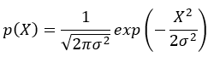

1. **Describe your calculation to obtain the posterior probability distribution.**

| posterior=likelihood.*prior; posterior=posterior/sum(posterior); |
| --- |

The prior is the probability distribution representing parameters before observing any data. In the code, the prior is specified as a normal distribution with mean 0 and standard deviation stdPrior. The likelihood, on the other hand, is the probability distribution of the observed data given a particular value of the parameter. Here, the likelihood is specified as a normal distribution with mean 2 and standard deviation stdLikelihood. The posterior distribution is obtained by multiplying the prior and likelihood element-wise and then normalizing the result. The resulting posterior distribution represents the updated parameters after observing the data. In other words, it combines the prior information with the evidence provided by the data.

1. **Describe what you see in the graph. Include a single plot with all three distributions using different colors.**

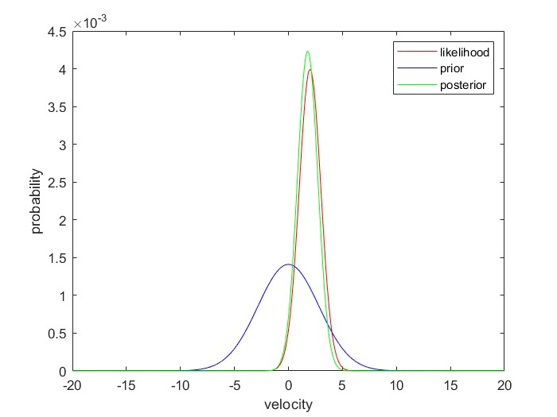

The graph shows three probability distributions, the likelihood in red, the prior in blue, and the posterior in green. The x-axis shows the velocity values and the y-axis shows the probability of that velocity value.

The likelihood distribution is centered around the mean value of 2 with a standard deviation of 1, which represents the belief in speed perception based on the sensory data. The prior distribution is centered around 0 with a standard deviation of 2, which represents the initial belief in speed perception based on prior knowledge or expectations. The posterior distribution, which is the combination of the likelihood and prior distributions, shows the updated belief in speed perception.

The posterior distribution is more peaked and narrower compared to the prior and likelihood distributions, which means the combination of sensory data and prior knowledge has reduced the uncertainty in the speed perception.

1. **Find the mean of the posterior distribution.**

| meanPosterior=sum(posterior.*samples) |
| --- |

The mean of the posterior distribution is calculated to be around 1.7778, which means the optimal response or estimate of the speed perception is around 1.7778. The mean of the posterior distribution is calculated by taking the sum of the element-wise product of the posterior distribution and the samples.

1. **Report the mean of the posterior distribution, reasoning on its value relative to the parameters given for the likelihood.**

The mean of the posterior distribution is 1.7778, which is almost the same as the mean of the likelihood distribution which is 2. This is because the prior distribution has a relatively low variance compared to the likelihood distribution, so it does not significantly shift the mean of the posterior distribution away from the mean of the likelihood distribution.

1. **Now try to change the standard deviation of the likelihood two times to different values and recalculate the posterior. Report your attempts (either in the form of a table or a graph). Include the mean of the posterior distribution and the standard deviation.**

| **Standard Deviation of Likelihood** | **Mean of Posterior Distribution** |
| --- | --- |
| 1 | 1.7778 |
| 2 | 1.3333 |
| 3 | 0.9412 |

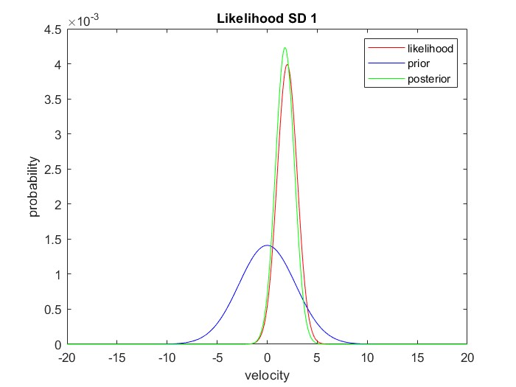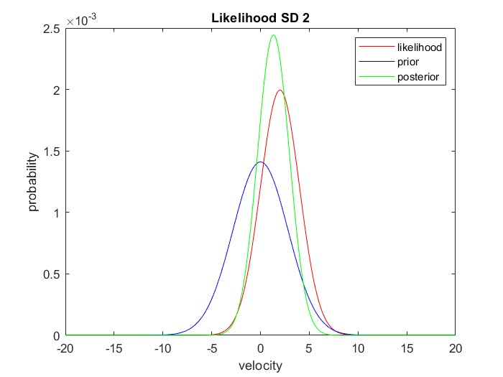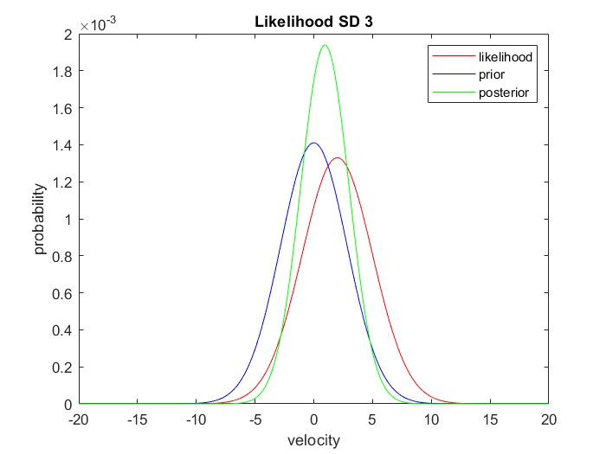

1. **Looking at the values, write a few sentences reasoning how the values relate to each other and the mean of the likelihood. Can you spot what the relation is? Can you tell why this pattern emerges?**

From the results, it is clear that as the standard deviation of the likelihood increases, the mean of the posterior distribution moves farther away from the mean of the likelihood. This trend can be observed from the table and the graph where the mean of the posterior distribution increases with increasing standard deviation of the likelihood. Also, the standard deviation of the posterior distribution increases as the standard deviation of the likelihood increases.

The reason for this pattern is that a larger standard deviation of the likelihood leads to a wider probability distribution, which in turn results in a flatter posterior distribution with a larger spread. As a result, the mean of the posterior distribution shifts towards the region where the likelihood is higher. This is known as the principle of maximum likelihood, which states that the maximum of the posterior distribution occurs at the point where the likelihood is highest.

1. **Describe in a couple of sentences whether/how this model captures the phenomenon described by Stocker et al.**

The model presented here captures the basic idea of Bayesian inference, where prior beliefs are updated using new information to generate a posterior distribution. This is similar to the way that Stocker et al. used sensory information to update their prior beliefs about the direction of motion of visual stimuli. However, the current model assumes that the likelihood is normally distributed, which may not always be the case in real-world scenarios. Additionally, the current model does not include any feedback mechanisms, which are thought to be important for improving the accuracy of perceptual judgments over time.

1. **Code for the lab.**

| %lab2 - Implementation of grid sampling Bayesian Inference % Used in MBM 2022/2023 to demonstrate scripting for workshop 2 % Will be distributed through Canvas % Students will rename the script, adding their ID to the name % % Description: % Bayesian Brain Hypothesis % % Other m-files required: none % MAT-files required: none %  % Author: Darshan Gohil % email: dxg288@student.bham.ac.uk % Date: 20/02/2023 % % Last revision: 20/02/2023, Author, Changes % 21/02/2023 Darshan updated graphs  % Set the standard deviation of the likelihood and prior stdLikelihood=1; stdPrior=2;  % Create an array of samples from -20 to 20 with a step size of 0.01 samples=-20:0.01:20;  % Compute the likelihood distribution using the normal probability density function with mean 2 and stdLikelihood standard deviation likelihood=normpdf(samples,2,stdLikelihood); % Normalize the likelihood distribution so that it integrates to 1 likelihood=likelihood/sum(likelihood);  % Compute the prior distribution using the normal probability density function with mean 0 and stdPrior standard deviation, and take the square root of the result prior=normpdf(samples,0,stdPrior).^.5; % Normalize the prior distribution so that it integrates to 1 prior=prior/sum(prior);  % Compute the posterior distribution as the element-wise product of the likelihood and prior distributions posterior=likelihood.*prior; % Normalize the posterior distribution so that it integrates to 1 posterior=posterior/sum(posterior);  % Plot the likelihood, prior, and posterior distributions on the same figure clf plot(samples,likelihood,'r') hold on plot(samples,prior,'b') plot(samples,posterior,'g') % Add a legend to the plot legend({'likelihood','prior','posterior'}) % Label the x-axis xlabel('velocity') % Label the y-axis ylabel('probability')  % Compute the mean of the posterior distribution by taking the dot product of the posterior and samples arrays meanPosterior=sum(posterior.*samples);  % Display the mean of the posterior distribution in the command window disp(['Mean of posterior distribution: ', num2str(meanPosterior)]); |
| --- |